
School of Science, Computing and Engineering Technologies

Object Oriented Programming
Pass Task 4.1: Drawing Program — Multiple Shape Kinds

Overview
In this task, you extend the ShapeDrawer application that you created in “3.3P Drawing Program – A Drawing Class.”

Purpose:

Task:
Learn to apply and use inheritance to create a family of related classes and objects, and experiment with polymorphism, a mechanism to interact with a group of related objects in an uniform way.
Extend the shape drawing program to allow for different types of shapes to be drawn on the screen. The task contains personalized requirements

Deadline: Due by the end of week five, Fri, 30 August 2024, 23:59:00 (Firmed).

Submission Details
All students have access to the Adobe Acrobat tools. Please print your solution to PDF and combine it with the screenshots taken for this task.
- C# code files of the classes created.
- Screenshot of running program (i.e., SplashKit window).



Instructions
Continue with the ShapeDrawer application that you developed in task 3.3P Drawing Program – A Drawing Class. You may want to archive your previous work before extending the applica- tion.
Currently, your program enables you to draw many shapes of the same type (i.e., rectangle). In this task, you extend your program to allow for many different types of shapes to be drawn (e.g., rectangles, circles, and lines). This requires additional program logic and techniques. In partic- ular, you will use inheritance to create a family of related classes and use method overriding to allow polymorphism in your application. Polymorphism is feature in object-oriented programming languages that permits a specific member function to use varying types of variables at different times.
The following UML class diagram illustrates the inheritance relationship that you are going to implement in this task. There are four classes: Shape, MyRectangle, MyCircle, and MyLine. Inheritance defines a “is-a” relationship between classes as well as objects (e.g., class MyRectangle is a kind of class Shape, MyRectangle objects are a kind of Shape objects). In UML, an inheritance relation is captured by drawing a line between the base class and the de- rived class with a hollow triangle pointing at the base class. So, in the UML diagram below, class Shape is that base class and the classes MyRectangle, MyCircle, and MyLine are the derived classes. (Please note that the base class is sometimes called parent class or super class, and the derived class is sometimes called inherited class or subclass.)
+ Shape()
+ Shape(color)

+ X : Float <<property>>
+ Y : Float <<property>>
+ Color : Color <<property>>
+ Selected : Boolean <<property>>

+ Draw() <<abstract>>
+ DrawOutline() <<abstract>>
+ IsAt(pt: Point2D) : Boolean <<abstract>>
- _color: Color
- _x: Float
- _y: Float
- _selected: Boolean
<<abstract>> Shape
Drawing

MyRectangle
- _width: Integer
- _height: Integer
+ MyRectangle()
+ MyRectangle(color, x, y, width, height)

+ Width : Integer <<property>>
+ Height : Integer <<property>>

+ Draw()
+ DrawOutline()
+ IsAt(pt: Point2D) : Boolean

MyCircle
- _radius: Integer
+ MyCircle()
+ MyCircle(color, x, y, radius)

+ Radius : Integer <<property>>

+ Draw()
+ DrawOutline()
+ IsAt(pt: Point2D) : Boolean

MyLine
- _endX: Float
- _endY: Float
+ MyLine()
+ MyLine(color, startX, startY, endX, endY)
+ EndX : Float <<property>>
+ EndY : Float <<property>>
+ Draw()
+ DrawOutline()
+ IsAt(pt: Point2D) : Boolean

Figure 1: Shape Hierarchy.
Please note that class Shape has been annotated with <<abstract>>. That is, you cannot create objects of class Shape any longer. In addition, the methods Draw, DrawOutline, and IsAt are all abstract now as well. This means, class Shape does not provide an implementation for those methods. They have to be implemented (or overridden) in the derived classes.

Note: Inheritance and polymorphism can be challenging concepts at first. Completing this task is the first step towards mastering them.
- Open your ShapeDrawing solution.
- Create a new class called MyRectangle.
- Make class Shape the base class of class MyRectangle.

public class MyRectangle : Shape
{
}
By making class Shape the base class of class MyRectangle allows class MyRectangle to inherit from class Shape. Class MyRectangle is a kind of Shape that knows its location, its size, its color, and whether it is selected. In addition, you can tell a MyRectangle object to Draw, to DrawOutline, and IsAt. The following UML fragment summarizes these facts.
+ Shape()

+ Color : Color <<property>>
+ X : Float <<property>>
+ Y : Float <<property>>
+ Width : Integer <<property>>
+ Height : Integer <<property>>
+ Selected : Boolean <<property>>

+ Draw()
+ DrawOutline()
+ IsAt(pt: Point2D) : Boolean
- _color: Color
- _x: Float
- _y: Float
- _width: Integer
- _height: Integer
- _selected: Boolean
Shape
Drawing
MyRectangle
Inheritance is primary mechanism for code reuse in object-oriented programming languages. Class MyRectangle is a fully functional class, due to inheriting and reusing all the code that you have defined in class Shape. Hence, you can use objects of class MyRectangle where objects of class Shape are expected.
- Go to the Main function in Program.cs.
- Locate the if-statement that checks whether the user has clicked the left mouse button. Substitute new Shape() with new MyRectangle() as shown below:
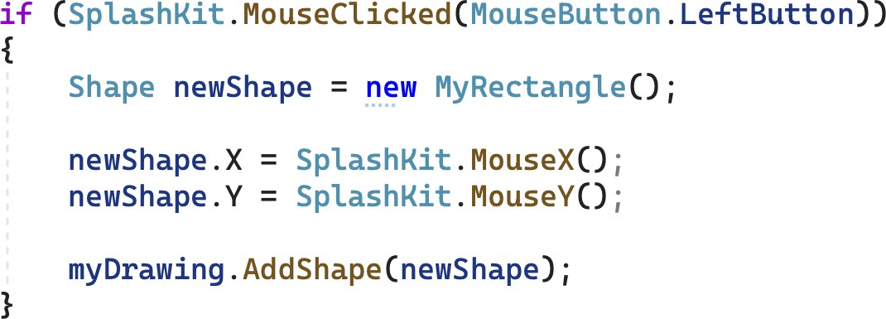

- Run the program and add some rectangles (drawn at the current mouse pointer position).
Your program works. It uses subtype polymorphism (sometimes also called inclusion poly- morphism), which allows objects of a subclass to be used in a context where an object of the base class is expected. Here, new MyRectangle() creates ab object of class MyRectan- gle, which is a subclass of Shape. You can assign this object to newShape, an object vari- able of class Shape. It works, because objects of class MyRectangle support all public meth- ods of class Shape. This also means, we can safely pass objects of class MyRectangle to the method AddShape even though method AddShape takes as parameter an object of class Shape.

Note: Polymorphism means “many forms”. It is one of the key features in object-oriented programming. There are four types of polymorphism (see the “On understanding types, data abstraction, and polymorphism” by Peter Wegner and Luca Cardelli for detailed analysis):
- Coercion:
float x = 10;
The integer literal 10 is converted (by the compiler) to a floating point value.
- Overloading:
FillRect(clr, x, y, w, h); and FillRect(clr, myRect);
There are two versions of method FillRect. Method FillRect is overloaded. The compiler uses the actual argu- ments passed to FillRect to select the best matching method.
- Subtype:
Shape myShape = new MyRectangle(); or
myDrawing.AddShape(new MyRectangle();
Objects of a subclass can be used in a context where an object of the base class is expected. This includes assignments, parameters, and results of functions.
- Universal:
List<Shape> or List<int>
Class List is parameterized over the type of values it can maintain. Universal polymorphism provides the means to define generic data types in C#. Objects of class List provide the same features, irrespective whether it is a List of Shapes or a List of ints.

- Create a new class called MyCircle, which is a subclass of Shape.
- In Program.cs, make the following changes to class Program:
  - Define a private enumeration called ShapeKind. This enumeration is used to deter- mine what shape the user wants to create.
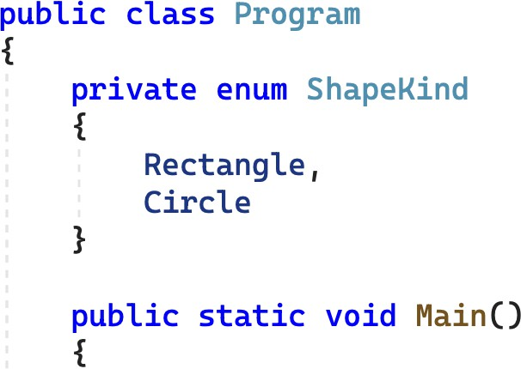

Note: In C#, you can declare types within other types. This type is encapsulated within its enclosing class. This can be a useful feature for types like enum ShapeKind, which should only be visible within class Program.

  - Create a ShapeKind variable in function Main called kindToAdd.
  - Initialize kindToAdd with ShapeKind.Circle.
  - Inside the event loop (after SplashKit.ClearScreen):
    - Add an if-statement to test if the user has typed the R-key (KeyCode.RKey). If this is true, set kindToAdd to ShapeKind.Rectangle.
    - Add an if-statement to test if the user has typed the C-key (KeyCode.CKey). If this is true, set kindToAdd to ShapeKind.Rectangle.
    - Update your code to allow for different shapes to be created. Use the following code as a guide.
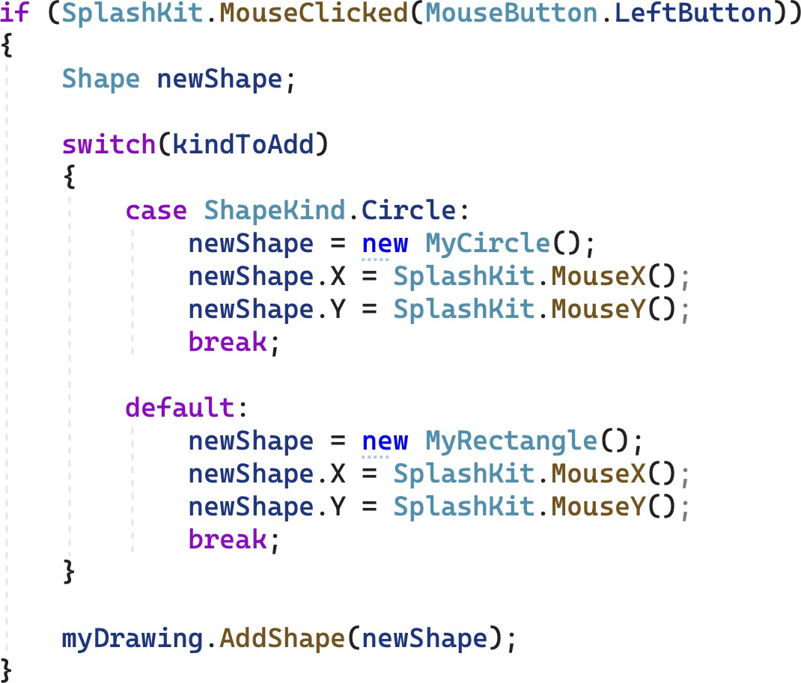

Note: Polymorphism allows you to assign objects of class MyCircle and MyRectangle to
myShape.
- The above contains code duplication to position the shape. This is unnecessary. All Shape
objects know their location. Fix the code duplication.
- Compile and run the program.
Unfortunately, all shapes are draws the same way – as rectangles. You have used inheritance to create different classes for MyRectangle and MyCircle. But their behavior is still identical. We need to override aspects of the behavior in class MyRectangle and MyCircle to allow these classes to represent different shapes. This will also require some updates in class Shape. Start with class MyCircle first.
- Add a _radius field that stores an integer value, and a Radius property to allow others to get and set the value of _radius.
- Add a constructor and set _radius to 50.
- Switch to class Shape. Decorate the methods Draw and DrawOutline as virtual. The Draw
method is shown below.
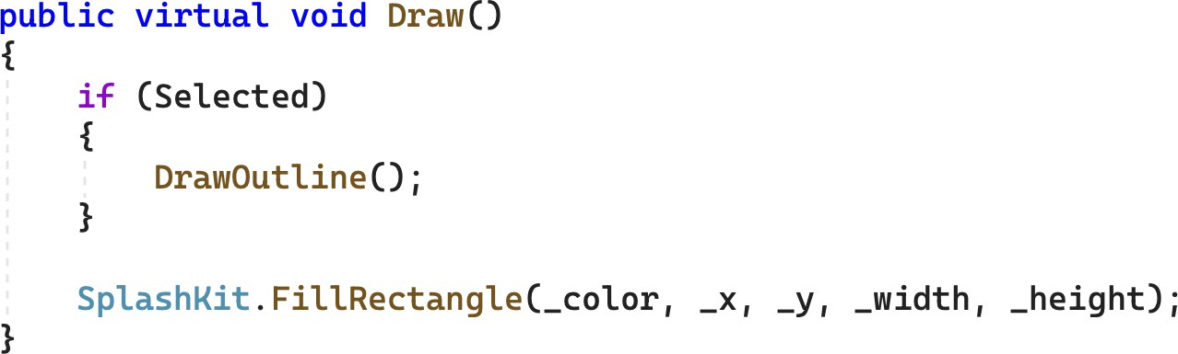

Note: Declaring a method as virtual in C# allows subclasses to override the method. In addition, virtual methods are subject to dynamic dispatch, a process of selecting which implementation of a overridden (polymorphic) method to call at run time.

- Return to class MyCircle and define an overridden version of method Draw. Use the follow- ing code as a guide.
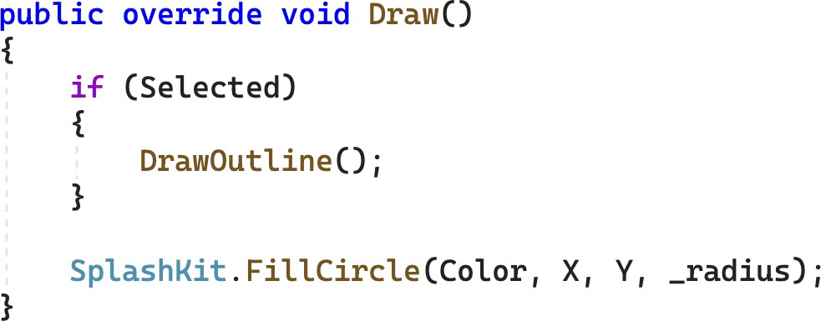

Tip: Visual Studio can help you when overriding methods. Just start typing override and the Visual Studio will give you a list of the methods you can override. By default it calls base.Draw() which calls the method from class Shape.

Note: The fields in the base class are private, so you need to use the public properties
Color, X, and Y to access the circle’s color and position.
- Run the program. Circles and Rectangles are drawn correctly now.
- In class MyCircle, override method DrawOutline and change it so that it draws a black circle with a radius 2 pixels larger than the circle's radius.
- Run the program again, and try selecting and deleting circles and rectangles.
You can create circles and rectangles. But not everything works, especially selecting and delet- ing circles. The main reason for this is that you have not defined a circle-specific method IsAt. In addition, our current code base does not reflect the design shown in Figure 1. You have only implemented the following UML diagram.
+ Shape()

+ Color : Color <<property>>
+ X : Float <<property>>
+ Y : Float <<property>>
+ Width : Integer <<property>>
+ Height : Integer <<property>>
+ Selected : Boolean <<property>>

+ Draw()
+ DrawOutline()
+ IsAt(pt: Point2D) : Boolean
- _color: Color
- _x: Float
- _y: Float
- _width: Integer
- _height: Integer
- _selected: Boolean
Shape
Drawing
MyRectangle

MyCircle
- _radius: Integer
+ MyCircle()

+ Radius : Integer <<property>>

+ Draw()
+ DrawOutline()

- Rework your classes Shape, MyRectangle, and MyCircle so that they match the following UML diagram:
+ Shape()
+ Shape(color)

+ Color : Color <<property>>
+ X : Float <<property>>
+ Y : Float <<property>>
+ Selected : Boolean <<property>>

+ Draw() <<virtual>>
+ DrawOutline() <<virtual>>
+ IsAt(pt: Point2D) : Boolean <<virtual>>
- _color: Color
- _x: Float
- _y: Float
- _selected: Boolean
Shape
Drawing
MyRectangle
- _width: Integer
- _height: Integer
+ MyRectangle()
+ MyRectangle(color, x, y, width, height)

+ Width : Integer <<property>>
+ Height : Integer <<property>>

+ Draw()
+ DrawOutline()
+ IsAt(pt: Point2D) : Boolean

- For class Shape:
MyCircle
- _radius: Integer
+ MyCircle()
+ MyCircle(color, x, y, radius)

+ Radius : Integer <<property>>

+ Draw()
+ DrawOutline()
+ IsAt(pt: Point2D) : Boolean

  - Move the _width and _height fields and the associated properties, Width
and Height, to class MyRectangle.
  - Add an overloaded Shape constructor that takes color as argument. It initial- izes the fields _x and _y with 0.0f and sets _color to color.
  - Change the default constructor. You use a this-call to another defined con- structor to initialize the object with Color.Yellow.
  - Change methods Draw and DrawOutline to have an empty method body.
  - Change method IsAt to be virtual and to return False.
- For class MyRectangle:
  - Define a constructor that accepts the color, the location (x, y), and the size (width, height) of the rectangle. This constructor must use a base-call to in- itialize the color in the base class Shape. Use the following code as a guide. You need to add a using declaration for SplashKitSDK so that type Color is defined.
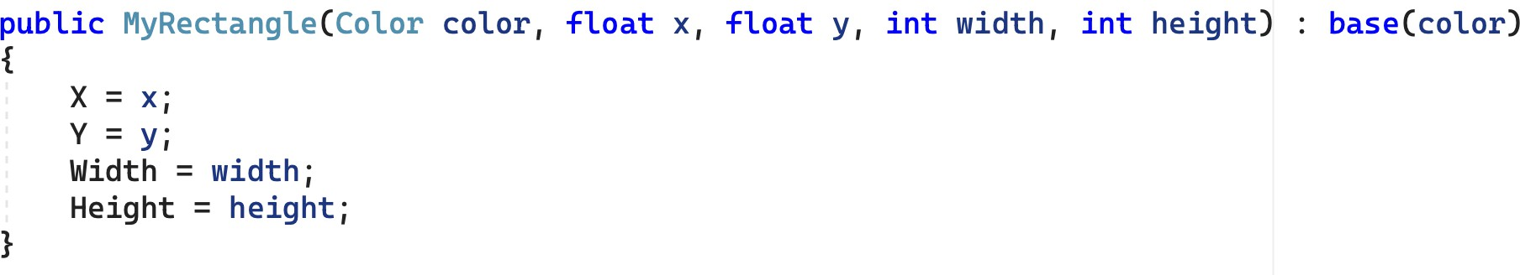

  - Define a default constructor. You use a this-call to another defined construc- tor to initialize the object with Color.Green for color, 0.0f for x and y, and (100+XX) for width and height, where XX is the last two digits of your ID.
  - Override the methods Draw, DrawOutline, and IsAt. Use corresponding Shape methods defined in task 3.3P Drawing Program – A Drawing Class as a guide.
- For class MyCircle:
  - Add an overloaded constructor that accepts a color and a radius. This con- structor must use a base-call to initialize the color in the base class Shape.
  - Change the default constructor. You use a this-call to another defined con- structor to initialize the object with Color.Blue for color, (50+XX) for radius. where XX is the last two digits of your ID.
  - Override method IsAt which checks if the point pt is within the area of the circle.

Tip: If the distance between the center of the circle and a given point does not exceed the radius of the circle, then the point is in the circle.
- Compile and run the program. Check that you can add, select, and delete both circles and rectangles.

Hint: SplashKit offers some helpful methods for implementing IsAt. Checkout PointInCircle and CircleAt for class MyCircle, and PointOnLine and LineFrom for class MyLine.
Everything works as expected. However, if you check the methods Draw, DrawOutline, and IsAt for class MyRectangle and MyCircle, then your notice that you have defined an overridden version for all and none of these overridden versions depends or uses the inherited code.
This is a common pattern in object-oriented design. You require all objects in a given class hierarchy to have a specific set of methods, so you introduce these methods in the root class of the class hierarchy. But only the subclasses define the actual behavior. The solution to this problem is that you declare the methods in the root class abstract. Abstract member functions have no implementation. Derived classes must implement abstract methods via method over- riding. In C#, a class that has abstract methods must be declared abstract also. You cannot create objects for abstract classes.

Note: Defining Draw, DrawOutline, and IsAt abstract promises that all shapes respond to these methods, but it is the derived classes of class Shape that fulfill this promise by implementing the methods.
- Decorate class Shape as abstract.

public abstract class Shape
{
…

Note: The word “abstract” occurs often in programming language terminology and can relate to distinct concepts. For example, an abstract class cannot be instantiated, that is, you cannot create objects for an abstract class. Abstract methods have no imple- mentation. They are part of the interface derived classes have to implement. Abstrac- tion (or data abstraction) is the process of generalizing concrete details. Abstraction allows for the separation of usage (interface) from representation (implementation) of data.

- Make method Draw in class Shape abstract.

public abstract void Draw();

Note: Abstract methods are implicitly virtual. A derived class must override it.

- Build and run the program. It should work as before.

Note: You program can no longer contain new Shape() or new Shape(color). Class
Shape is abstract and you cannot create objects of class Shape.
- Make methods DrawOutline and IsAt in class Shape abstract also. (Method IsAt in class
Shape is no longer required to return a Boolean value.)
- Build and run the program again. It works.

- Add a new class, named MyLine, that implements the necessary features to be a kind of
Shape. Refer to Figure 1 and classes MyRectangle and MyCircle for guidance.

Note: By default, objects of class MyLine are drawn in red. In addition, you only have access to the mouse pointer position for the start of the line. For the endpoint, use hard- coded values of your choosing.

Hint: To create the outline of a MyLine object, draw small circles around the start and end points of the line.

Adjust Program so that you can add X lines after you have typed the L key, where X is the last digit of your student ID. If X=0, you can reassign X=5.
- Run the program. You should be able to add circles, rectangles, and lines, select them, and removing them.

Once your program is complete you can prepare it for your portfolio. This can be placed in your portfolio as evidence of what you have learnt.
- Review your code and ensure it is formatted correctly.
- Run the program and use your preferred screenshot program to take a screenshot of the Terminal showing the program's output.
- Save and backup your work to multiple locations, if possible.
  - Once you your program is working you do not want to lose your work.
  - Work on your computer’s storage device most of the time, but backup your work when you finish each task.
  - You may use a cloud storage provider to safely store your work.
USB and portable hard drives are good secondary backups, but there is a risk that the drive gets damaged or lost.
Once your program is working correctly you can prepare it for your portfolio. Add a screenshot of the program working, and your source code.

Assessment Criteria
Make sure that your task has the following in your submission:
- The “Universal Task Requirements” (see Canvas) have been met.
- Your program (as text or screenshot).
- Screenshots of running program (i.e., SplashKit window) that show the different aspects of the application: adding shapes, selecting shapes, and removing shapes.

using System;
using System.Security.Cryptography.X509Certificates;
using SplashKitSDK;

namespace ShapeDrawer3
{
public class Program
{
private enum ShapeKind
{
Rectangle,
Circle,
Line
}
public static void Main()
{
ShapeKind kindToAdd = new ShapeKind();
kindToAdd = ShapeKind.Circle;
Drawing myDrawing = new Drawing();
Window window = new Window("ShapeDrawer", 800, 600);
SplashKit.MouseClicked(MouseButton.LeftButton);
SplashKit.MouseX();
int LineX = 9;
int index = 0;

do
{
SplashKit.ClearScreen();

myDrawing.Draw();
Console.WriteLine(index);
if (SplashKit.KeyTyped(KeyCode.RKey))
{
kindToAdd = ShapeKind.Rectangle;
}
if (SplashKit.KeyTyped(KeyCode.CKey))
{
kindToAdd = ShapeKind.Circle;
}
if (SplashKit.KeyTyped(KeyCode.LKey))
{
kindToAdd = ShapeKind.Line;
}

if (SplashKit.MouseClicked(MouseButton.RightButton))
{

myDrawing.SelectShapesAt(SplashKit.MousePosition());
}
if (SplashKit.MouseClicked(MouseButton.LeftButton))
{

Shape newShape;

switch (kindToAdd)
{
case ShapeKind.Line:
newShape = new MyLine();
newShape.X = SplashKit.MouseX();
newShape.Y = SplashKit.MouseY();
break;
case ShapeKind.Circle:
newShape = new MyCircle();
newShape.X = SplashKit.MouseX();
newShape.Y = SplashKit.MouseY();
break;
default:
newShape = new MyRectangle();
newShape.X = SplashKit.MouseX();
newShape.Y = SplashKit.MouseY();
break;
}
if (index >= 9 && kindToAdd == ShapeKind.Line)
{

}
else
{
myDrawing.AddShape(newShape);
}
if (index < 9)
{

}

if (kindToAdd == ShapeKind.Line && index <= 9)
{
index++;
}

}
if (SplashKit.KeyTyped(KeyCode.SpaceKey))
{
myDrawing.Background = SplashKit.RandomColor();
}
if (SplashKit.KeyTyped(KeyCode.BackspaceKey))
{
if (kindToAdd == ShapeKind.Line)
{
index = index -1;
myDrawing.RemoveShape();
}
else
{

}

}
if (SplashKit.KeyTyped(KeyCode.DeleteKey))
{
if (kindToAdd == ShapeKind.Line)
{
index--;
myDrawing.RemoveShape();

}
else
{
myDrawing.RemoveShape();
}
}

SplashKit.ProcessEvents();
SplashKit.RefreshScreen();
} while (!window.CloseRequested);

}
}
}

using SplashKitSDK;
using System;
using System.Collections.Generic;
using System.Linq;
using System.Text;
using System.Threading.Tasks;

namespace ShapeDrawer3
{
internal class Drawing
{
private readonly List<Shape> _shapes;
private Color _background;

public Drawing(Color background)
{
_background = background;
_shapes = new List<Shape>();
}
public Drawing() : this(Color.White)
{

}
public Color Background
{
get
{
return _background;
}
set
{
_background = value;
}
}
public int ShapeCount
{
get
{
return _shapes.Count;
}
}

public void AddShape(Shape shape)
{
if (shape != null)
{
_shapes.Add(shape);
}
}

public void RemoveShape()
{
foreach (Shape _shape in _shapes.ToList())
{
if (_shape.Selected)
{
_shapes.Remove(_shape);
}
}
}

public void Draw()
{

SplashKit.ClearScreen(_background);
foreach (Shape _shape in _shapes)
{

_shape.Draw();
}

}
public void SelectShapesAt(Point2D pt)
{
foreach (Shape _shape in _shapes)
if (_shape.IsAt(pt))
_shape.Selected = true;
else
_shape.Selected = false;
}
public void SelectedShapes()
{
foreach (Shape _shape in _shapes)
if (_shape.Selected)
AddShape(_shape);
return;
}

}
}

using SplashKitSDK;
using System;
using System.Collections.Generic;
using System.Linq;
using System.Text;
using System.Threading.Tasks;

namespace ShapeDrawer3
{
public abstract class Shape
{
public Color _color;
public float _x;
public float _y;
public bool _selected;

public Shape()
{
_color = Color.Azure;
_x = X;
_y = Y;

}
public Shape(Color color)
{
_color = color;
_x = 0.0f;
_y = 0.0f;
}
abstract public void Draw();

public abstract bool IsAt(Point2D pt);

public bool Selected
{
get { return _selected; }
set { _selected = value; }
}
public abstract void DrawOutline();

public float X
{
get
{
return _x;
}
set
{
_x = value;
}
}

public float Y
{
get
{
return _y;
}
set
{
_y = value;
}
}

}

}

using SplashKitSDK;
using System;
using System.Collections.Generic;
using System.Linq;
using System.Text;
using System.Threading.Tasks;

namespace ShapeDrawer3
{
public class MyCircle : Shape
{
public int _radius;

public MyCircle() : this (Color.Blue, 50 + 19)
{
_radius = 50;

}
public MyCircle(Color color, int radius) : base(color)
{
Radius = radius;

}

public int Radius
{
get
{
return _radius;
}
set
{
_radius = value;
}
}

public override void Draw()
{
if (Selected)
{
DrawOutline();
}
SplashKit.FillCircle(_color, _x, _y,
_radius);

}
public override void DrawOutline()
{
SplashKit.FillCircle(Color.Black, _x, _y,
_radius + 2);
}
public override bool IsAt(Point2D pt)
{
double a = (double)(pt.X - X);
double b = (double)(pt.Y - Y);
if (Math.Sqrt(a * a + b * b) < _radius)
{
return true;
};
return false;
}
}
}

using SplashKitSDK;
using System;
using System.Collections.Generic;
using System.Linq;
using System.Text;
using System.Threading.Tasks;

namespace ShapeDrawer3
{
public class MyRectangle : Shape
{
public int _width;
public int _height;

public MyRectangle(Color color, float x, float y, int width, int height) : base(color)
{
X = x;
Y = y;
Width = width;
Height = height;
}
public MyRectangle() : this (Color.Green, 0.0f, 0.0f, 100 + 19, 100 + 19)
{

}
public int Width
{
get
{
return _width;
}
set
{
_width = value;
}
}

public int Height
{
get
{
return _height;
}
set
{
_height = value;
}
}

public override void Draw()
{
if (Selected)
{
DrawOutline();
}
SplashKit.FillRectangle(_color, _x, _y,
_width, _height);

}
public override bool IsAt(Point2D pt)
{
return pt.X >= X && pt.X <= X + _width &&
pt.Y >= Y && pt.Y <= Y + _height;
}
public override void DrawOutline()
{
SplashKit.FillRectangle(Color.Black, _x - 7, _y - 7,
_width + 14, _height + 14);
}
}
}

using System;
using System.Collections.Generic;
using System.Linq;
using System.Text;
using System.Threading.Tasks;
using SplashKitSDK;

namespace ShapeDrawer3
{
public class MyLine : Shape
{
public float endX;
public float endY;

public MyLine(Color color, float startX, float startY, float endX, float endY) : base(color)
{
X = startX;
Y = startY;
EndX = endX;
EndY = endY;
}
public MyLine() : this(Color.Red, 0.0f, 0.0f, 100, 100)
{

}
public float EndX
{
get
{
return endX;
}
set
{
endX = value;
}
}

public float EndY
{
get
{
return endY;
}
set
{
endY = value;
}
}

public override void Draw()
{
if (Selected)
{
DrawOutline();
}
SplashKit.DrawLine(_color, _x, _y,
endX, endY);

}
public override bool IsAt(Point2D pt)
{
return pt.X >= X && pt.X <= X + EndX &&
pt.Y >= Y && pt.Y <= Y + EndY;
}
public override void DrawOutline()
{
SplashKit.DrawLine(Color.Black, _x, _y,
endX, endY);
}
}
}

